Q1.
.Create a Person class with private instance variables for the person’s name and birth date. Add appropriate accessor methods for these variables. Then create a subclass College Graduate with private instance variables for the student’s GPA and year of graduation and appropriate accessors for these variables. Include appropriate constructors for your classes. Then create a class with main() method that demonstrates yourclasses

import java.util.* ;
class Person{
private String name ;
private Date dob ;
public Person(){
name = "";
dob = new Date() ;
}
public Person(String name, Date dob){
this.dob = dob ;
//this.dob.year = this.dob.year-1900 ;
this.name = name ;

}
public void set_name(String name){
this.name = name ;
}
public String get_name(){
return this.name ;

}
public void set_dob(int year,int month,int day){

this.dob = new Date(year-1900,month,day) ;

}
public Date get_dob(){
return this.dob ;
}
}

class CollegeGraduate extends Person{
private float gpa ;
private int grad_year ;
public CollegeGraduate(){
super();
gpa = 0 ;
grad_year = 0;
}
public CollegeGraduate(String name, Date dob, float gpa , int grad_year){
super(name,dob);
this.gpa = gpa ;
this.grad_year = grad_year ;
}
public void set_gpa(float gpa){
this.gpa = gpa ;
}
public float get_gpa(){
return this.gpa ;
}
public void set_grad(int grad_year){
this.grad_year = grad_year ;
}
public int get_grad(){
return this.grad_year ;
}
}

public class Persondemo{
public static void main(String[] args){
Scanner sc = new Scanner(System.in);
Date d = new Date(2000-1900,9,3) ;
CollegeGraduate cg1 = new CollegeGraduate("Akshat Chand",d,9.4f,2023) ;
System.out.println("Details of College graduate are:");
System.out.println("Name :"+cg1.get_name()+"\tDate of Birth "+cg1.get_dob()+"\nGPA "+cg1.get_gpa()+"\tGraduation Year "+cg1.get_grad());
Person p = new Person() ;
System.out.println("Enter Date of birth, year, month and date");
int year,month,date ;
year = sc.nextInt();
month = sc.nextInt();
date = sc.nextInt();
System.out.println("enter Name of person ");
sc.nextLine();
String name = sc.nextLine();
p.set_dob(year,month,date);
p.set_name(name) ;
System.out.println("Details of the person are using accessor methods") ;
System.out.println("Name :"+p.get_name()+"\t\tDate of birth :"+p.get_dob());

}
}

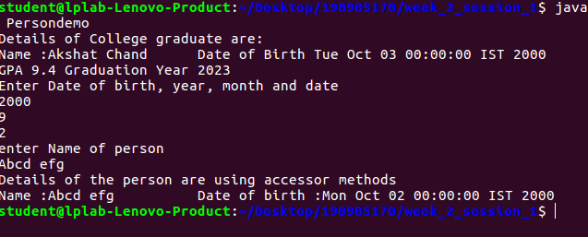
Q2

Define a class Maximum with the following overloadedmethods
a.max (which finds maximum among three integers and returns the maximum integer)b.max (which finds maximum among three floating point numbers and returns the maximum amongthem)c.max (which finds the maximum in an array and returnsit)d.max (which finds the maximum in a matrix and returns theresult)Place this in a package called p1. Let this package be present in a folder called “myPackages”, which is a folder in your present working directory (eg: c\student\3rdsem \mypackages\p1). Write a main method to use the methods of Max class in a package p1.

package p1 ;
public class Maximum{
public int maax(int a,int b,int c){
if(a>b){
if (a>c)
return a ;
else
return c ;
}
else {
if(b>c)
return b ;
else
return c ;
}
}

public float maax(float a,float b,float c){
if(a>b){
if (a>c)
return a ;
else
return c ;
}
else {
if(b>c)
return b ;
else
return c ;
}
}

public int maax(int[] arr){
int largest,n ;
n= arr.length ;
largest = arr[0];
for(int i =0;i<n;i++){
if (arr[i] > largest )
largest = arr[i];
}
return largest ;

}
public int maax(int[][] matrix,int r,int c){
int largest = matrix[0][0] ;
for(int i=0 ;i<r;i++){
for(int j=0;j<c ;j++){
if (matrix[i][j]>largest)
largest= matrix[i][j] ;
}
}
return largest ;
}

}

import java.util.*;
import p1.* ;

public class Maxtest{
public static void main(String[] args){
Scanner sc = new Scanner(System.in);
System.out.println("Enter 3 integers tp find max");
int a, b, c ;
a = sc.nextInt();
b = sc.nextInt();
c = sc.nextInt();
int largest = 0 ;

Maximum m1 = new Maximum() ;
largest = m1.maax(a,b,c);
System.out.println("Largest is "+largest);

System.out.println("Enter 3 float numbers to find max");
float p,q,r,l = 0 ;
p = sc.nextFloat();
q = sc.nextFloat();
r = sc.nextFloat();
l = m1.maax(p,q,r);
System.out.println("Largest is "+l);

System.out.println("Enter length of array");
int n ;
n = sc.nextInt();
int arr [] = new int[n];
System.out.println("enter elements of array");
for(int i=0 ; i< n ; i++){
arr[i] = sc.nextInt();

}

largest = m1.maax(arr) ;
System.out.println("Largest is "+largest);

int[][] mat = new int[3][4] ;
System.out.println("enter elements of matric");
for(int i=0;i<3;i++){
for(int j=0 ;j<4;j++){
mat[i][j] = sc.nextInt();
}
}

largest = m1.maax(mat,3,4);
System.out.println("Largest is "+largest);

}
}

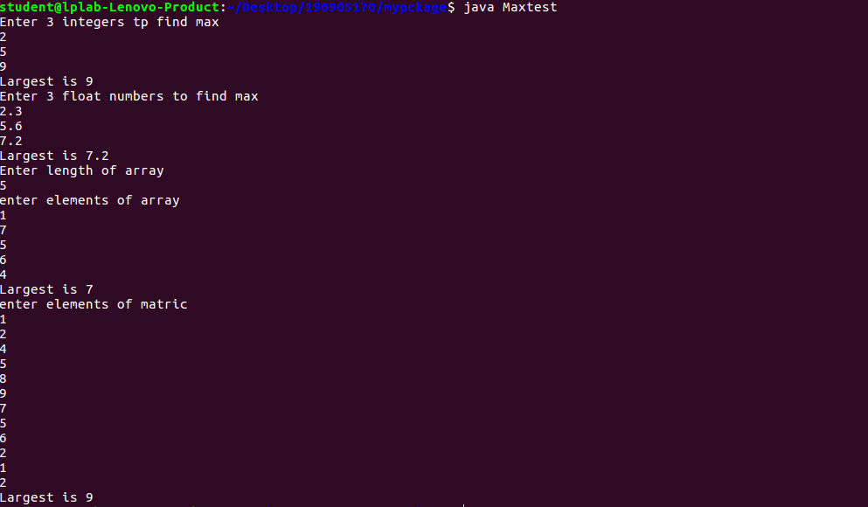

Q3 Create an abstract class Figure with abstract method area and two integer dimensions. Create three more classes Rectangle, Triangle and Square which extend Figure and implement the area method. Show how the area can be computed dynamically during run time for Rectangle, Square and Triangle to achieve dynamic polymorphism. (Use the reference of Figure class to call the three different area methods)

import java.util.* ;
abstract class Figure {
int dim1 ;
int dim2 ;
public Figure(int a , int b){
this.dim1 = a ;
this.dim2 = b ;
}
abstract float area();

}
class Rectangle extends Figure{
public Rectangle(int a , int b){
super(a,b);
}

float area(){
System.out.println("Area for rectangle");
return (dim1*dim2) ;

}

}

class Triangle extends Figure{
public Triangle(int a, int b){
super(a,b);
}
float area(){
System.out.println("area for triangle ");
return dim1*dim2 /2 ;
}

}

class Square extends Figure{
public Square(int a){
super(a,a);
}
float area(){
System.out.println("area of Square");
return (dim1*dim2) ;
}
}

public class abstractdemo{
public static void main(String[] args){
Scanner sc = new Scanner(System.in);
System.out.println("enter the dimensions of the rectangle");
int l,b = 0 ;
l = sc.nextInt();
b = sc.nextInt();
Rectangle r1 = new Rectangle(l,b);
System.out.println("enter the dimensions of the triangle");
l = sc.nextInt();
b = sc.nextInt();
Triangle t1 = new Triangle(l,b) ;
System.out.println("enter dimension of square");
l = sc.nextInt();
Square s1 = new Square(l);
Figure f1 ;
f1 = r1 ;
System.out.println();
System.out.println(f1.area()) ;
System.out.println();
f1 = t1 ;
System.out.println();
System.out.println(f1.area());
System.out.println();
f1 = s1 ;
System.out.println();
System.out.println(f1.area());
System.out.println();

}
}

